**Morse Code**

**Overview**

[Morse Code](https://en.wikipedia.org/wiki/Morse_code) is delivered in a series signals which are referred to as dashes (-) or dots (.). To keep things simple for the purposes of this challenge we'll only decode letters with a **maximum length of three signals**.

1:1

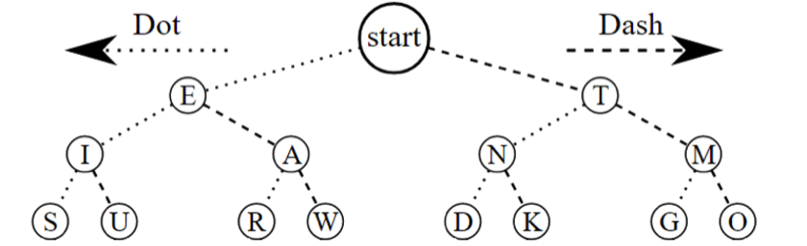

Here is the Morse Code [dichotomic search](https://en.wikipedia.org/wiki/Dichotomic_search) table courtesy of [Wikipedia](https://commons.wikimedia.org/wiki/File:Morse_code_tree3.png)

**Morse Code Examples**

-.- translates to K  
... translates to S  
.- translates to A  
-- translates to M  
. translates to E

**Background**

You've started work as morse code translator. Unfortunately some of the signals aren't as distinguishable as others and there are times where a . seems indistinguishable from -. In these cases you write down a ? so that you can figure out what all the posibilities of that letter for that word are later.

**Task**

Write a function possibilities that will take a string signals and return an array of possible characters that the Morse code signals could represent.

**Specification**

**possibilities(signals)**

**Parameters**

signals: ***String*** - The Morse code signals that needs to be parsed. The may contain one or more unknown signals (?).

**Return Value**

***Array<String>*** - The list of possible letters for the given group of signals. **Letters will always be ordered from how they appear on the chart, from left to right**.

**Constraints**

There will be no more than 3 characters within signals.

0 - 3 unknown signals may be given.

**Examples**

| **signals** | **Return Value** |
| --- | --- |
| "." | ["E"] |
| "-" | ["T"] |
| "-." | ["N"] |
| "..." | ["S"] |
| "..-" | ["U"] |
| "?" | ["E","T"] |
| ".?" | ["I","A"] |
| "?-?" | ["R","W","G","O"] |